Software Requirements

Specification

Message board system

Softuni Team Pablich project

**Table of Contents**

1. Introduction 3

1.1 Purpose 3

1.2 Scope 3

1.3 Definitions, acronyms, and abbreviations 3

1.4 Overview 3

2. Overall description 4

2.1 System environment 4

2.2 Actors 4

2.3 User interfaces 4

2.3.1 Personal information 5

3. Specific requirements 5

3.1 Functional requirements 6

3.1.1 Use case 1 – Accessing the system 6

3.1.2 Use case 2 - User registration 6

3.1.3 Use case 3 - User login 6

3.1.4 Use case 4 - Loading message board 6

3.1.5 Use case 5 – Creating new message 6

3.1.6 Use case 6 – Deleting messages 6

3.2 Technical requirements 7

3.2.1 User/admin requirements: 7

3.2.2 Server requirements for installation and running the system: 7

# Introduction

## Purpose

The purpose of this document is to give a detailed description of the requirements for the “Message board system” (MBS) software. It will illustrate the purpose and complete declaration for the development of system. This document is intended as a guide for users of MBS and as a reference for the development team.

## Scope

The “Message board system” is application for communication by posting messages on the board, which are visible for every registered user. Users can write messages to the board and delete their own posts.

The application should be accessible online at: http://www.palachinka.bg/msg-board/.

An administrator also uses the web-portal in order to administer the system and keep the information accurate.

Furthermore, the software needs Internet connection. All system information is maintained in a database, which is located on a web-server.

## Definitions, acronyms, and abbreviations



**Table 1 - Definitions**

|  |  |
| --- | --- |
| **Term** | **Definition** |
| User | Any person who has interaction with the system who is not a developer |
| Admin/Moderator | System administrator who is given specific permission for managing and controlling the system |
| Web-Portal | A web application which present special facilities the administrator |

## Overview

This document includes three chapters. The second one provides an overview of the system functionality.

The third chapter is written primarily for the developers and describes in technical terms the details of the functionality of the product. Both sections of the document describe the same software product in its entirety, but are intended for different audiences and thus use different language.

# Overall description

This section will give an overview of the whole system. The system will be explained in its context and introduce the basic functionality of it.

## System environment

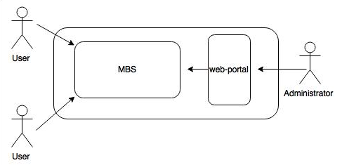

**Figure 1 – System environment**

## Actors

There are two types of actors that interact with the system: users and administrator. Each of these types of users has different use of the system so each of them has their own requirements.

**The users** can only use the application to login the system and post or delete message.

**The admin** only interact with the web portal. The admin can delete all messages and users, but cannot edit messages, usernames or passwords. Also can read the passwords.

## User interfaces

A first-time user of the system should see the log-in page when he/she opens the application, see Figure 2. When the user is logged in, the message board should be displayed – Figure 3. If the user has not registered, he/she should be able to do that on the log-in page, through the link for registration – Figure 4. All access of the inner pages are linking to the login/register page if the user is not already registered. The system uses cookie to store the login information without any passwords or personal information.

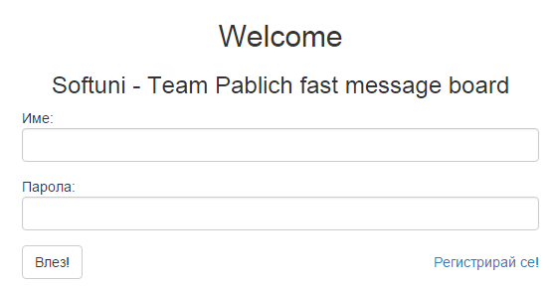

**Figure 2 - Login page**

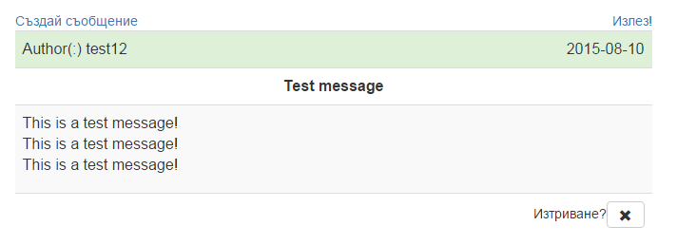

**Figure 3 – Message board**

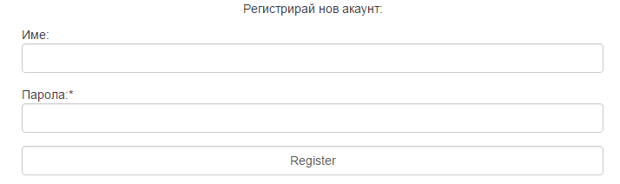

**Figure 4 – Registration**

## Personal information

There is an important warning in the registration page, which claims that the passwords are not specially protected or cached, and easily could be seen by anybody with access to the database.

# Specific requirements

## Functional requirements

This section includes the requirements that specify all the fundamental actions of the software system.

## Use case 1 – Accessing the system

The system is accessed through the internet from its initial URL.Requires internet access. The user should register or log in to use the MBS.

## Use case 2 - User registration

User should be able to register through the link “Register”. Two fields are shown: Username and Password, where the user should input respective information. The username should be minimum 5 symbols. After filling the register form with valid information, user should click “Registration” button to create account. The user cannot use username, that already exist in the database, alert message „Вече има потребител с това име“ will display if the username is existing. In case of successful registration, the user should be redirected to the Message board.

## Use case 3 - User login

## 

A user should be able to log in using valid username and password. There is no access to this page, if the user is already logged in. The system will automatically trim all white symbols at the beginning and at the end of the username and password. Alert message “Грешно потребителско име/ парола.” has to be displayed in case of entering of invalid credentials.

## Use case 4 - Loading message board

After the user is logged in, the message board should be displayed. There is no access to this page if the user is logged out. The user can see all messages from other users containing the text of the message, author and date of the post.

## Use case 5 – Creating new message

The user can create new message by clicking “Create new message” in the upper left corner, above the message box. User should be logged in to do this. When “Create new message” is clicked, the user should fill the title field and the message text box. The title should contain minimum 5 and maximum 50 symbols. The message box field should contain minimum 5 and maximum 500 symbols. Afterwards, the user should click “Send” button and the message should be posted on the board. If the content of the title or message text are incorrect, after clicking the „Send” button” the message will not be posted on the board and the user should fill the fields correct. Alert message should be displayed in case of incorrect content.

## Use case 6 – Deleting messages

The user should be able to delete his own messages. When the user is logged in and the message board is displayed, in the bottom right corner below the user’s messages should be positioned “Delete” button. By clicking the button, the message above should disappear/be deleted, after the user confirmation. Pop-up window or new page should appear with the message “You will permanently delete your message after clicking the OK button!”

## Technical requirements

## User/admin requirements:

* Web browser
* Internet connection

## Server requirements for installation and running the system:

* PhP 5+
* MySQL